COLEMAN UNIVERSITY Computer Information Systems Name: Michael Fetick
COM 280 Object Oriented Analysis and Design Student No. 84270
NOTE: The Syllabus, the Course Schedule and the Student Manual were provided only on a hard-copy media. After these class notes were typed, I have not transferred my written notes to text yet.
Sequence Diagram
My Notes
Sequence diagram: Messages, sequence of messages: input, output messages.
Messages show flow of information.

Exercises – Sequence Diagrams
COLEMAN UNIVERSITY Computer Information Systems Name: Michael Fetick
COM 280 Object Oriented Analysis and Design Student No. 84270
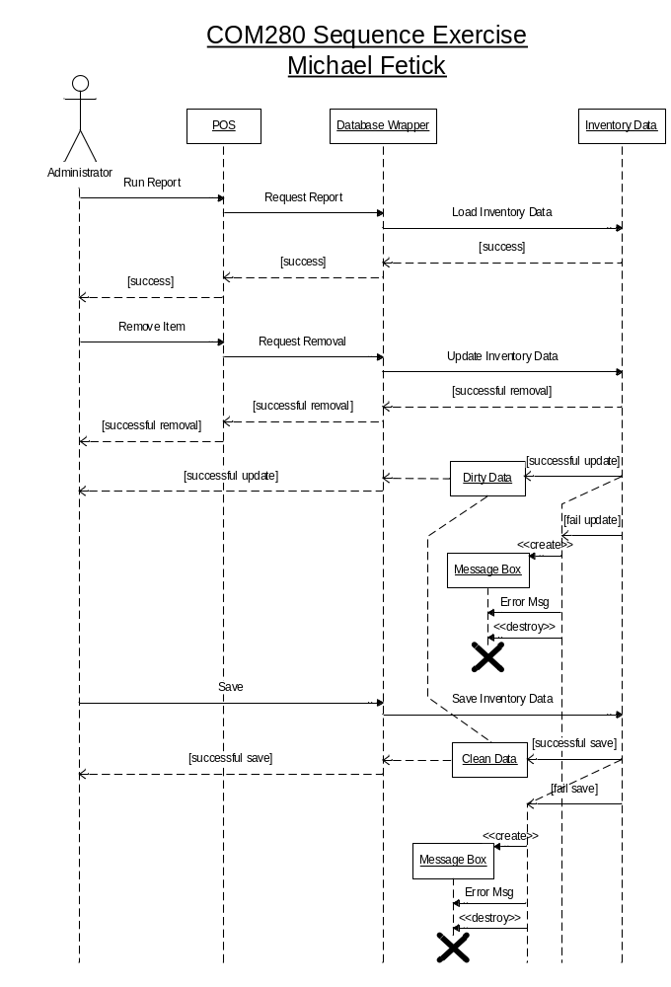
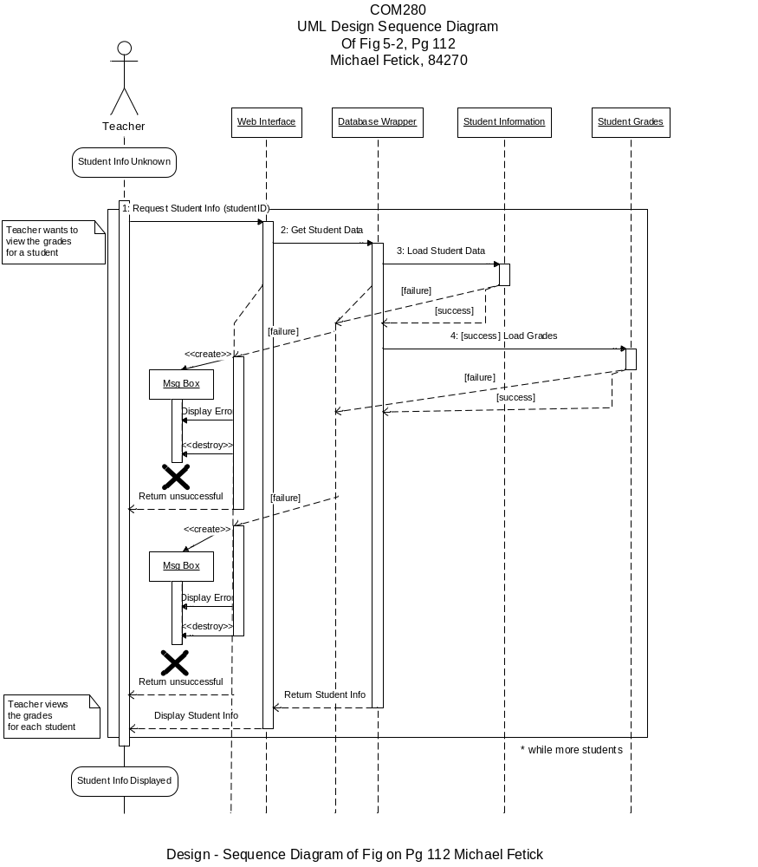
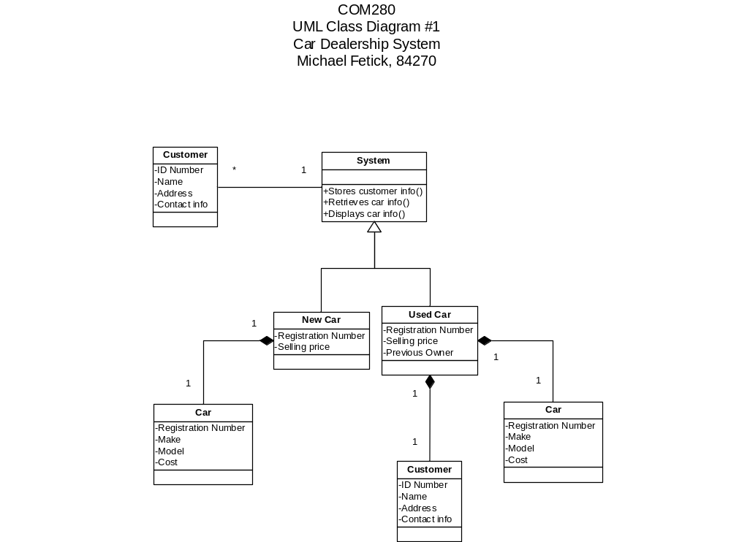
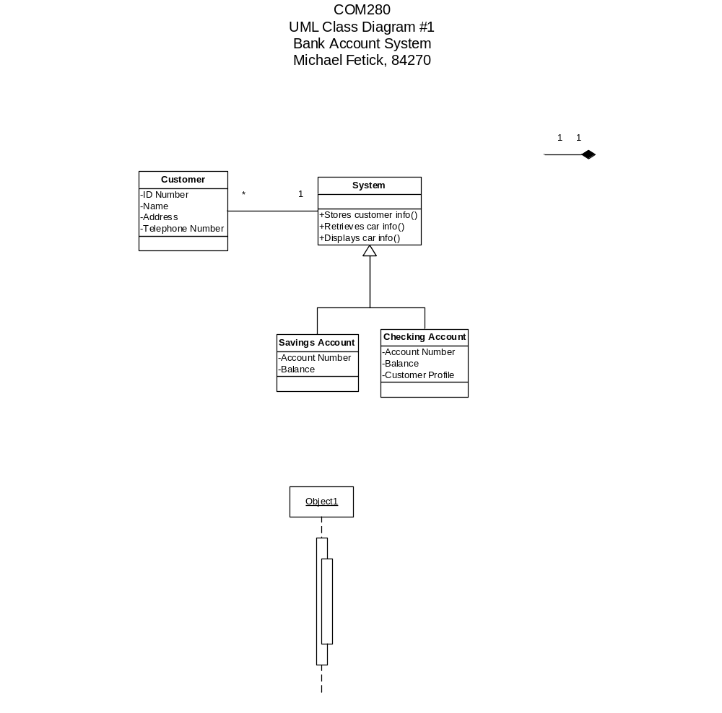

Project 3 – Sequence Diagram
COM280 Project 3
Sequence Diagram
5 points
Develop a sequence diagram for: Make Old Patient Appointment Use Case. Need to include the following components in your diagram:
- Active objects – actors and objects
- 4 different types of messages
- States
- Branching and alternate flows
- Creating objects
Refer to: R:\COM280\Carol Koon Assignments\June 2013 Projects\Project 3 Sequence Diagram\Make Old Patient Appointment Use Case.pdf
Due date: Thursday, 6/25/2013 11:30 p.m. PDT.
Email project to ckoon@coleman.edu
Details
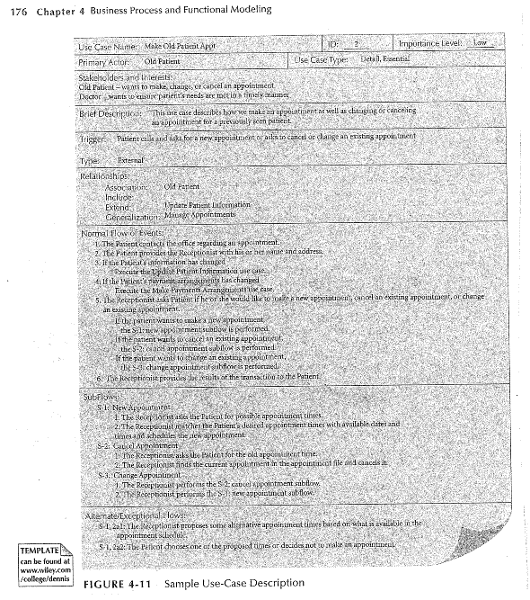

COLEMAN UNIVERSITY Computer Information Systems Name: Michael Fetick
COM 280 Object Oriented Analysis and Design Student No. 84270
